# Specification document

**Project Name:** **Virtual Key for Your Repositories/ LockedMe.com**

**Introduction:**

This project is developed as a prototype for Company Lockers Pvt. Ltd digitizing their products.

**Vision/ Mission:** The vision / mission of this project is to digitize and optimize the application of for Company Lockers Pvt. Ltd called LockedMe.com.

**Technology used:**

* Eclipse/Intelli J
* Java Programming language
* GitHub
* Scrum

**Requirements:**

* + Require an option for users to retrieving the file names in an ascending order
    - Provide an option to add a user specified file to the application
    - Provide an option delete a user specified file from the application
    - Provide an option search a user specified file from the application
    - Provide an option to close the current execution context and return to the main context
  + Provide an option to close the application
  + Make sure to avoid application termination abruptly by handling Exceptions and using condition checks.

**Features:**

1. The welcome screen displays the project name and developer details along with the following options.

*******************Welcome***********************

* Developer: Arulselvi Amirrthalingam *

* @@@@@@@@@@@@@@@@@@@@@@@@@@@@@@@@@@@@@@@@@@@ *

*************************************************

-------------------------------------------------

Please Select from the following options

*************************************************

* 1. Retrieve files in Ascending order *

* 2. Select to see more options *

* 3. Close the Application *

*************************************************

1. Option1: **Retrieve files in Ascending order** retrieves the already existing files from the root directory and list them in the ascending order.
2. Option 2: **Select to see more options** provides the following options for user to choose

*************************************************

* 1. Add a file *

* 2. Delete a file *

* 3. Search for file *

* 4. Navigate to the main context *

*************************************************

1. **Add file:**

This option allows user to add files to the root directory**.**

1. **Delete a file:**

This option allows user to delete files from the root directory**.**

1. **Search for file:**

This option allows user to search for files by giving name from the root directory**.**

1. **Navigate to the main context:**

This option takes back to the main context.

1. Option 3: **Close the Application** closes the Application.

**Screen shots of the Project**

**Welcome Screen:**

*******************Welcome***********************

* Developer: Arulselvi Amirrthalingam *

* @@@@@@@@@@@@@@@@@@@@@@@@@@@@@@@@@@@@@@@@@@@ *

*************************************************

-------------------------------------------------

Please Select from the following options

*************************************************

* 1. Retrieve files in Ascending order *

* 2. Select to see more options *

* 3. Close the Application *

*************************************************

**Business/File Operations**

Please Select from the following options

*************************************************

* 1. Add a file *

* 2. Delete a file *

* 3. Search for file *

* 4. Navigate to the main context *

*************************************************

**Screen shots of project flow:**

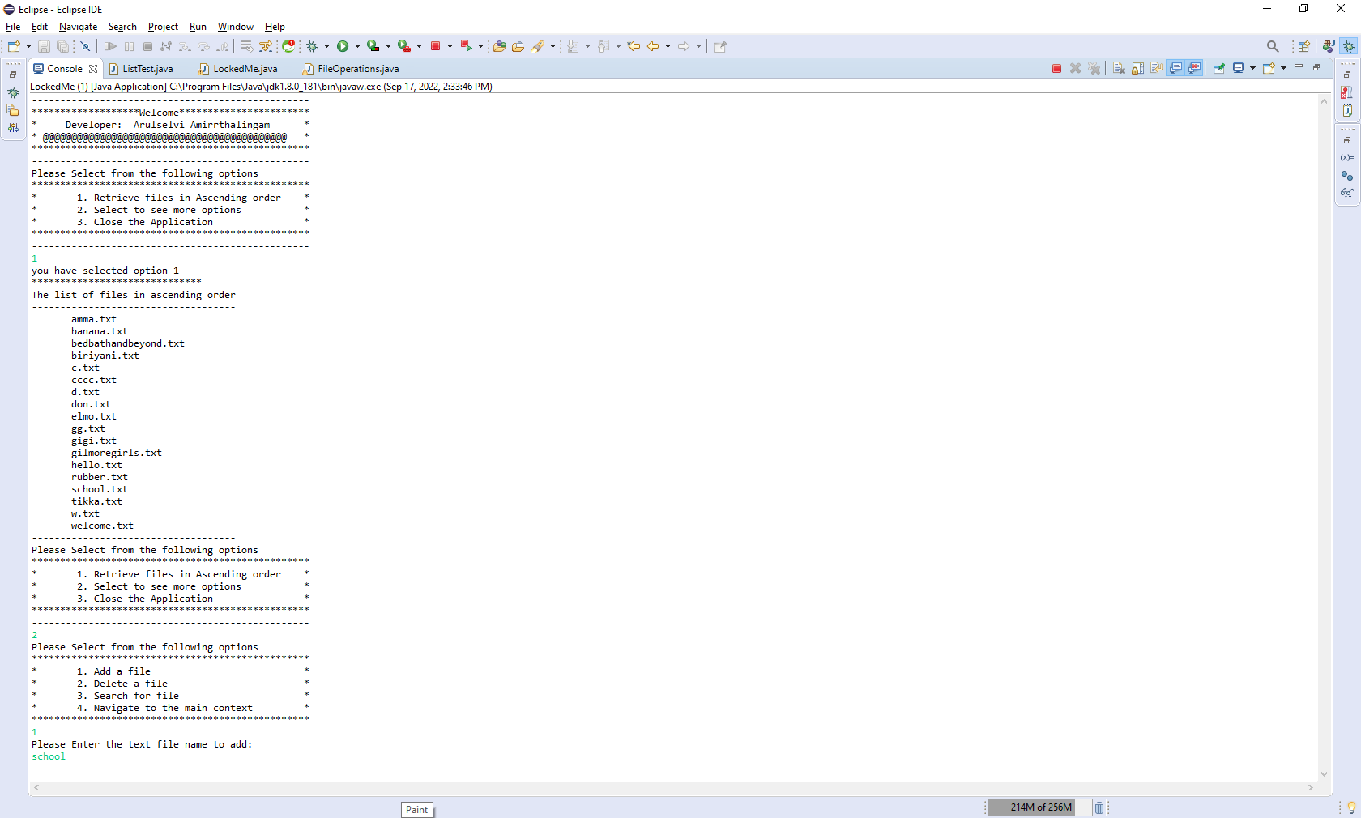

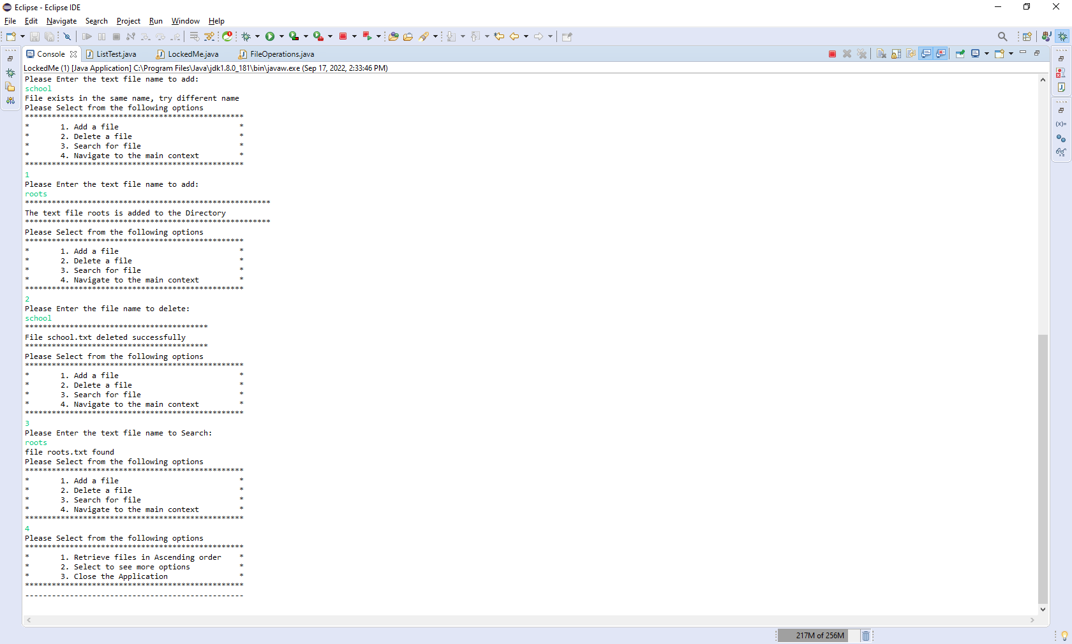

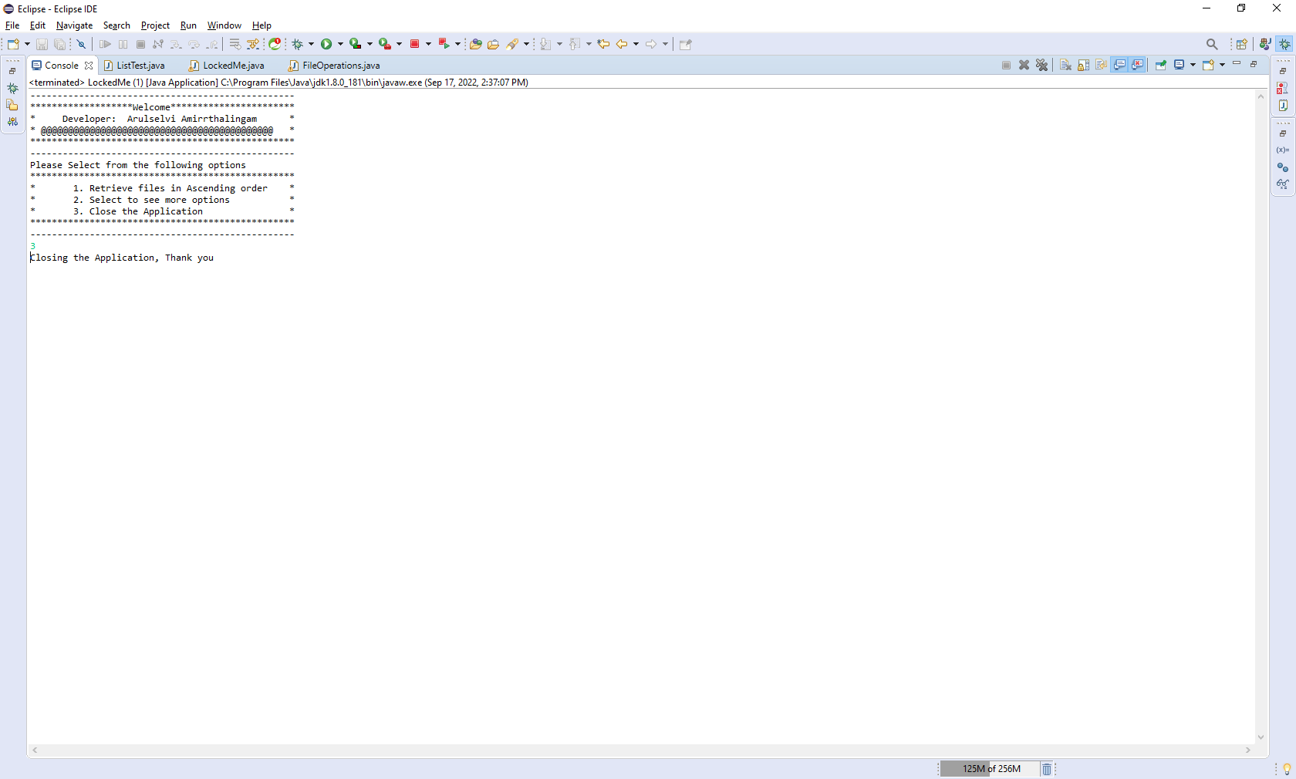

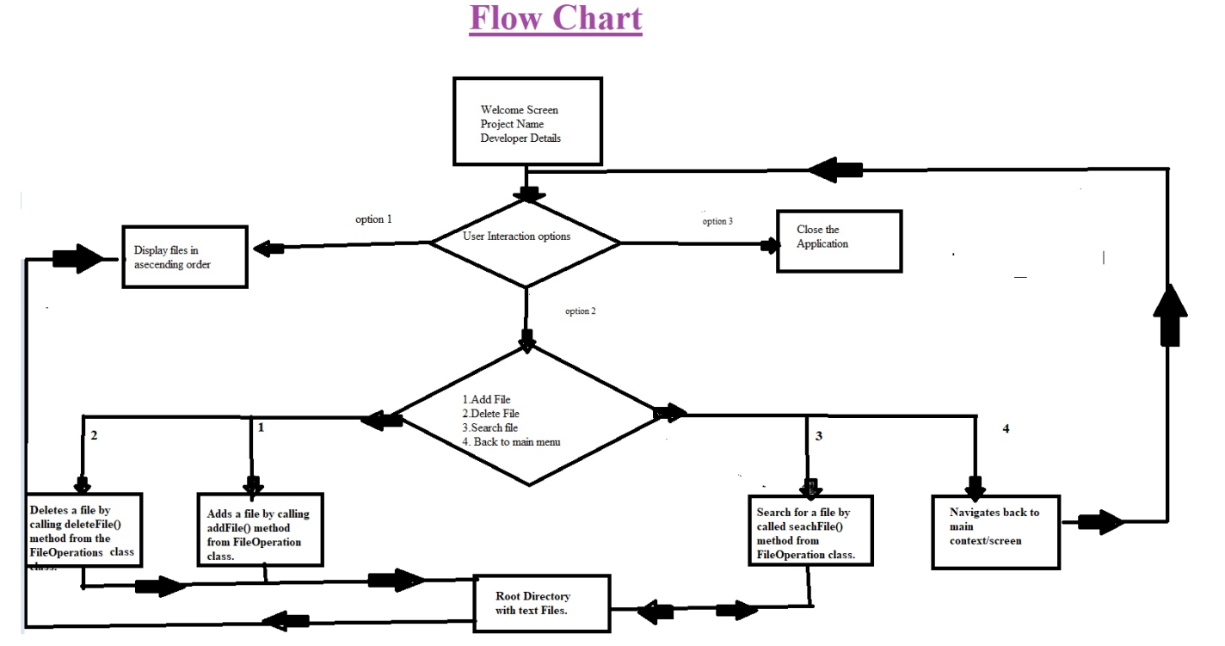

**Core Concepts used in the Project:**

* Java Files
* Collection/List
* OOPS concepts-Inheritance
* Functions
* Exception/Handling
* String methods
* Scanner class
* Iteration/loops

**Conclusion:**

Enhancing the application and defining the USPs (Unique Selling Points):

This Project can be enhanced by building GUI (Graphical User Interface) to make it more user friendly instead of command prompt. By building GUI, the project will be easy to interact by users.